**Docker & Kubernetes**

Imp. Points

> I have DB application, laptop, mysql installed on laptop, mysql 5.7 is installed

> is it possible for me to deploy another mysql db with same version on laptop ------No for this version at least, for version up to 8

> concept of VM

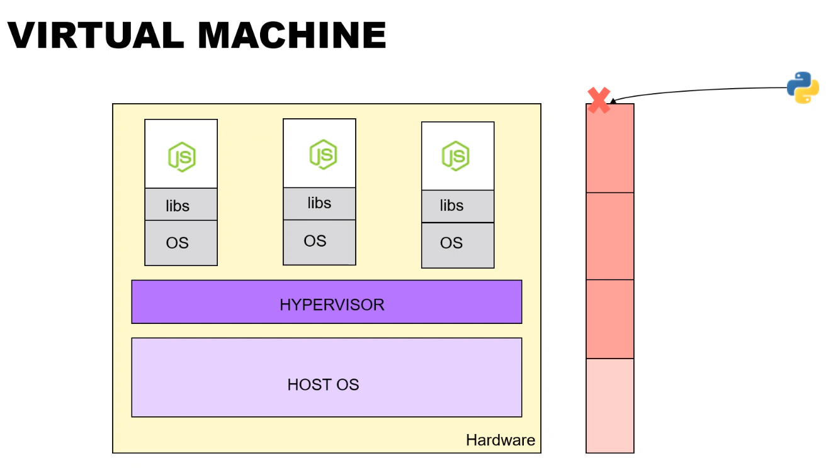

> VM will also require separate OS & shared resources as source machines. It’s more like blotting.

> Resources will get exhausted in the concept of VM.

> VM was good for 2005, 2010-11. For better VM, we have to increase resources/servers.

> These were the challenges in VM

> Scalability in vm is bad as if we deploy both front & back end application on same vm, scalability is same for both js & python or different vm as js will get more request than python.

Concept of container (base os, docker runtime engine)

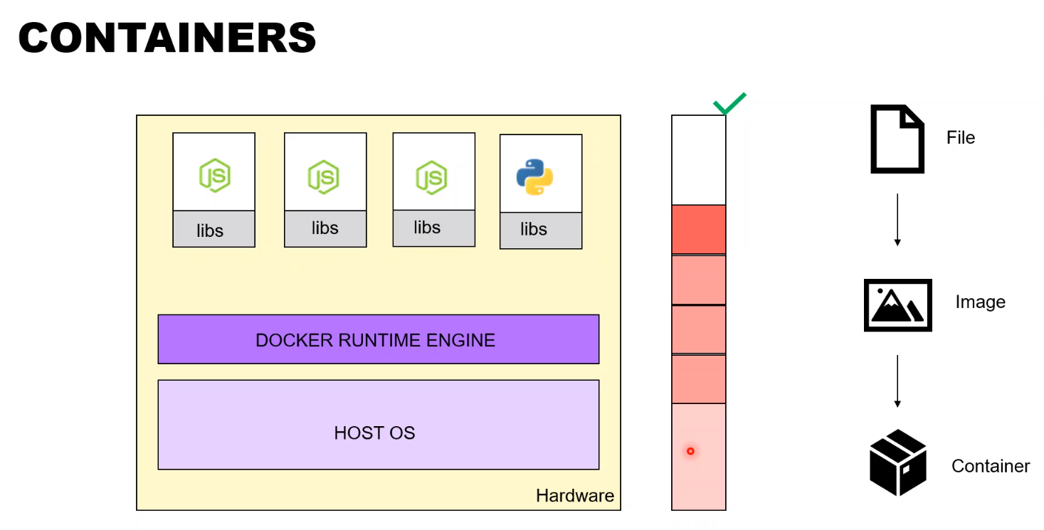

> step by step instruction to be followed for containization of your application

1. File

2. Image

3. Container

> docker composed file/ manifest file – instruction file, libraries

> image of application taken care by docker.

> File will be converted to image. Docker will create the image from file.

> Now that image will be deployed on the container [Isolated box]

> No explicit OS involved here.

> We can introduce python as a separate container.

> Whatever the base OS, it will be shared among the containers.

> We can now scale so it’s better than VM.

> If it works in docker same as local, will run the same as on production.

> Container as a service is booming.

> Open shift is user-friendly has UI. Docker has command-line interface. OpenShift running on top of docker & Kubernetes.

> Docker Playground - <https://labs.play-with-docker.com/>

> Need to learn linux command

> Naming convention is there in docker….. create a file with name Dockerfile

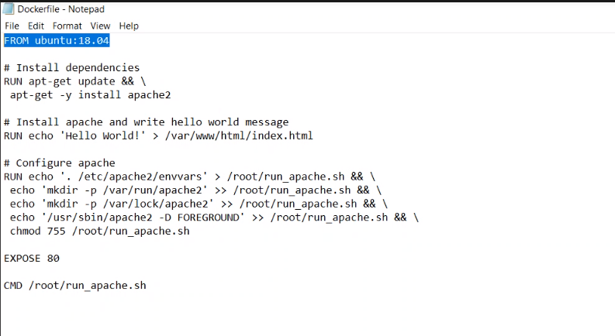

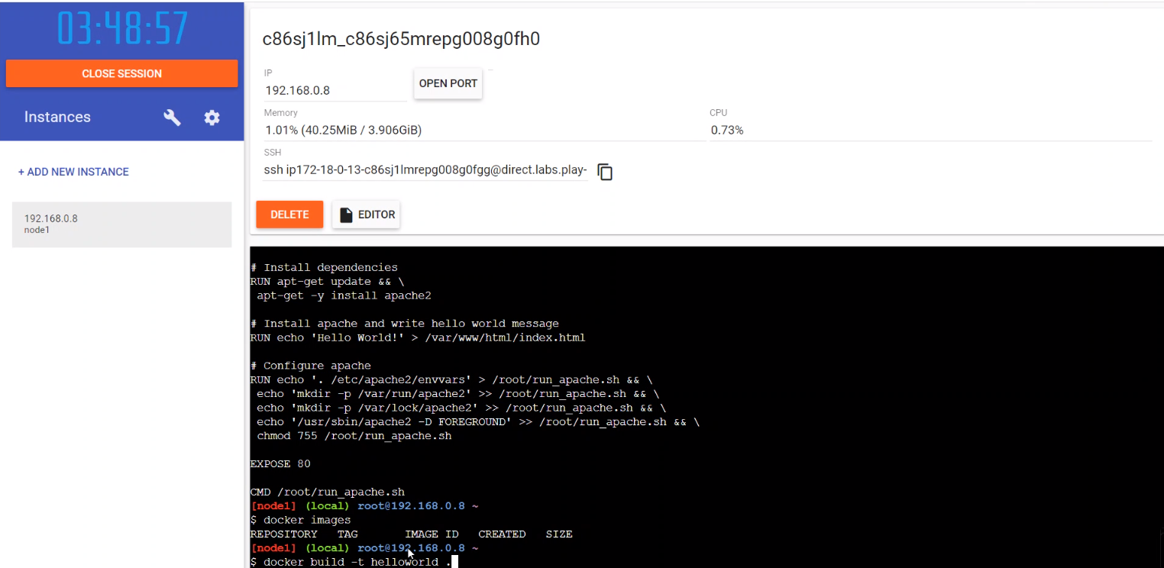

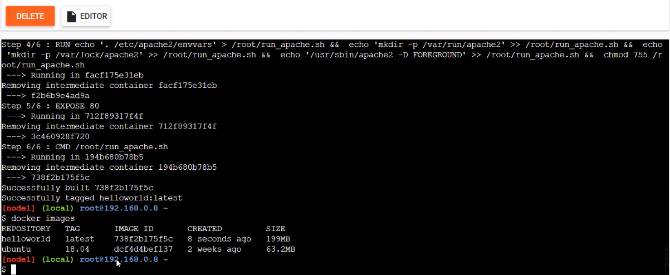

> ubuntu is base image

> helloworld has packaged all the informations we will deploy helloworld. We can even remove ubuntu. As helloworld is having ubuntu inside it.

> reuse the existing image

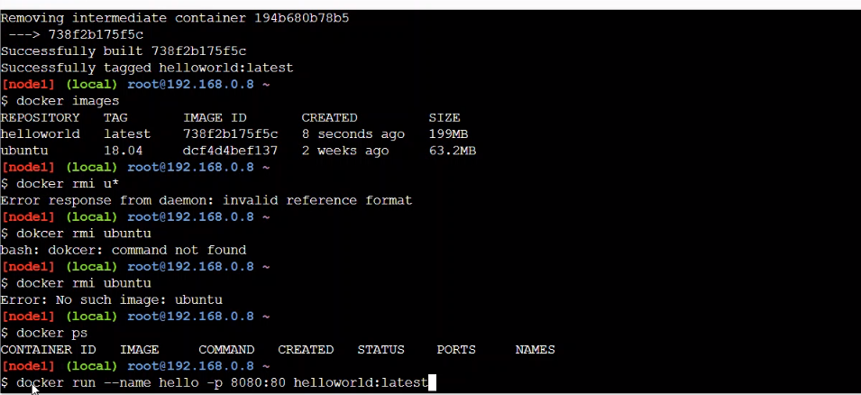

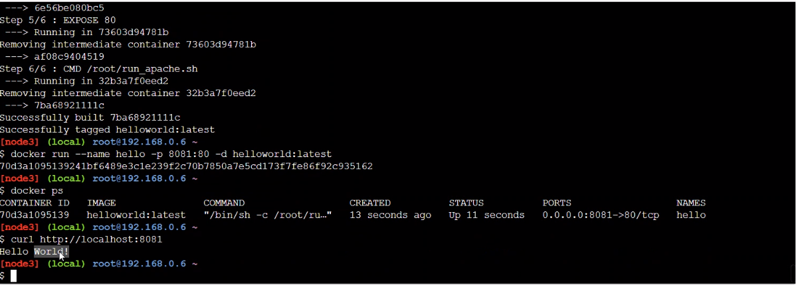

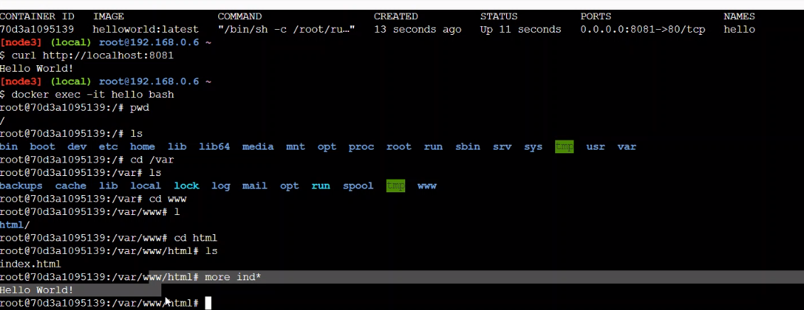

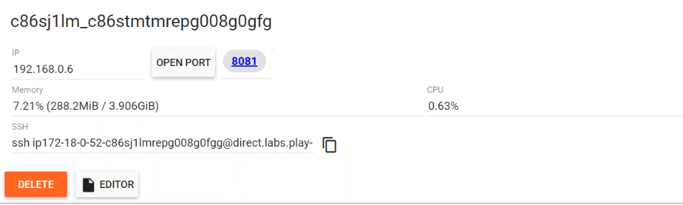

On 8081, there will be a url

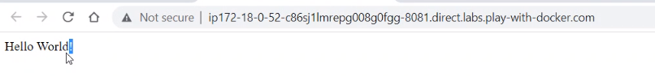

> Detach means running the process in background. Command is -d

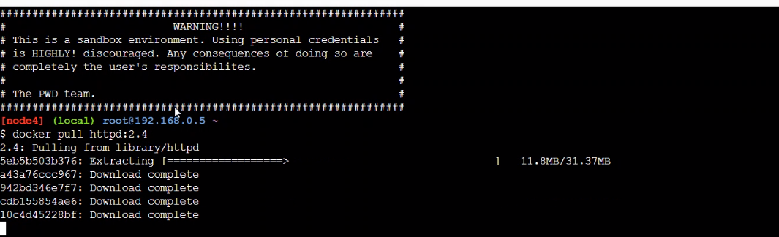

Image pull from docker hub

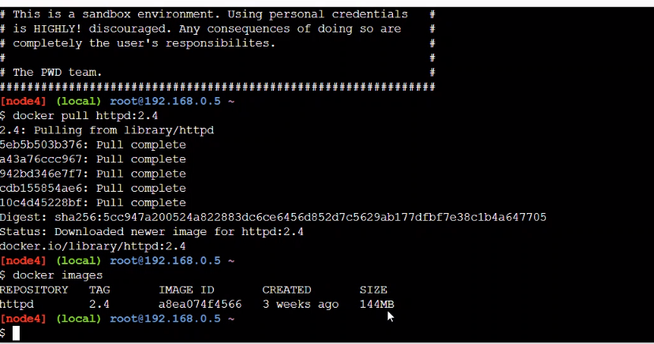

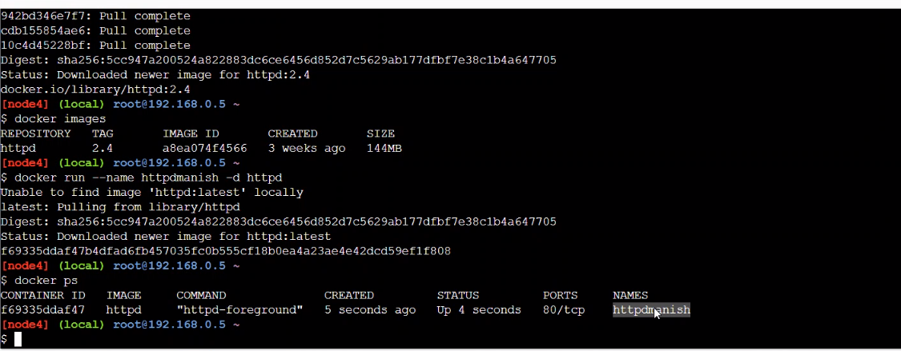

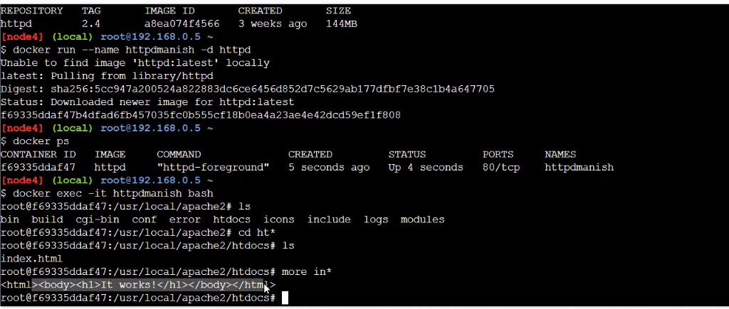

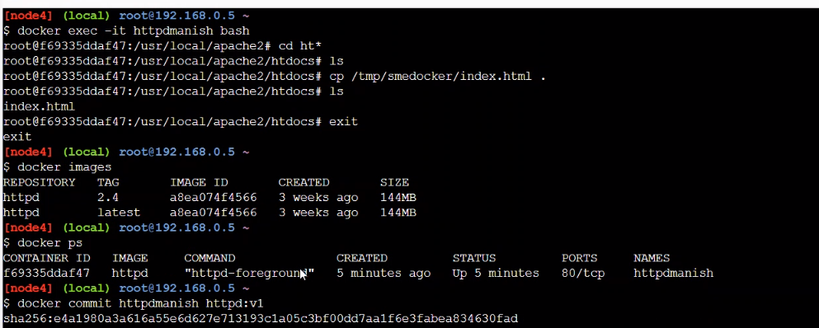

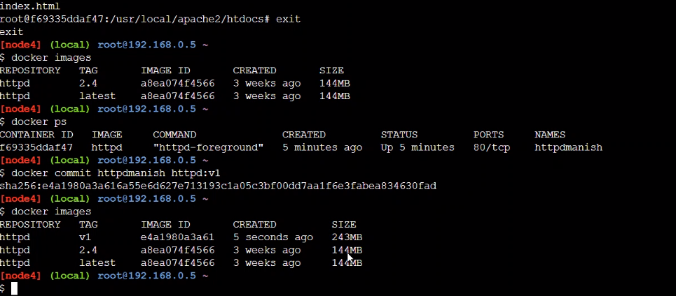

> Don’t keep anything unwanted becoz it will increase size. Delete smedocker & git app

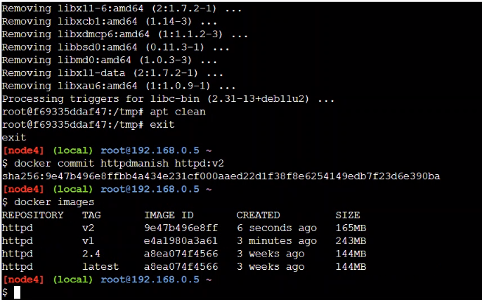

> After clean up, httpd:v2 is only 165MB

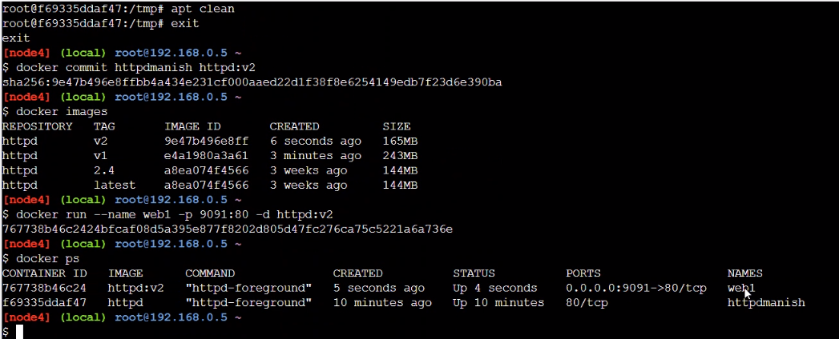

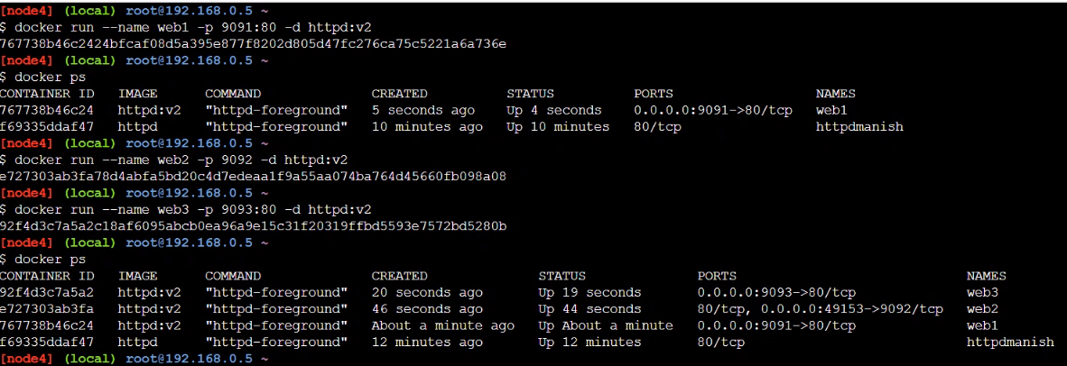

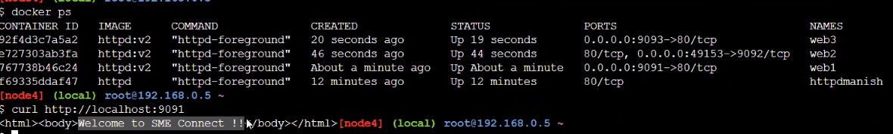

> Load balancer

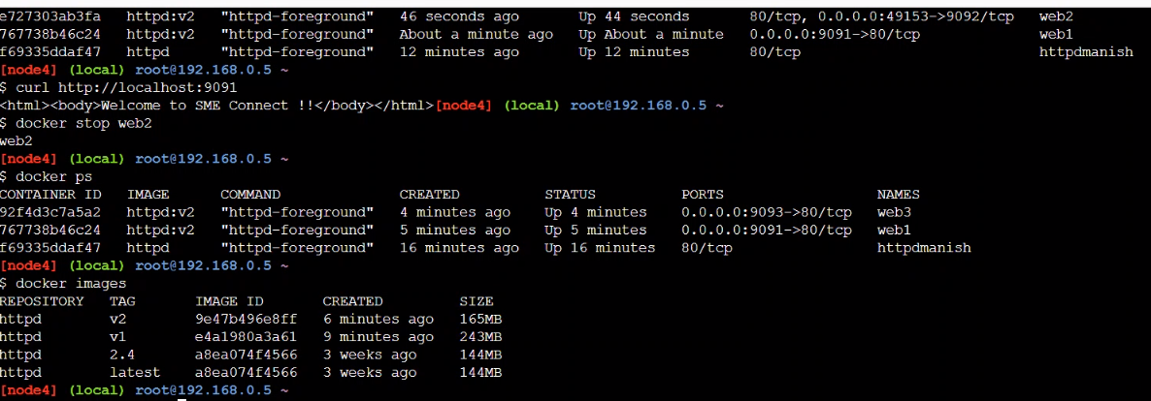

> Kuburnetes is orchestration i.e., manage the container. Or docker node

> Scalability

> Relicate

> orchestration of container.

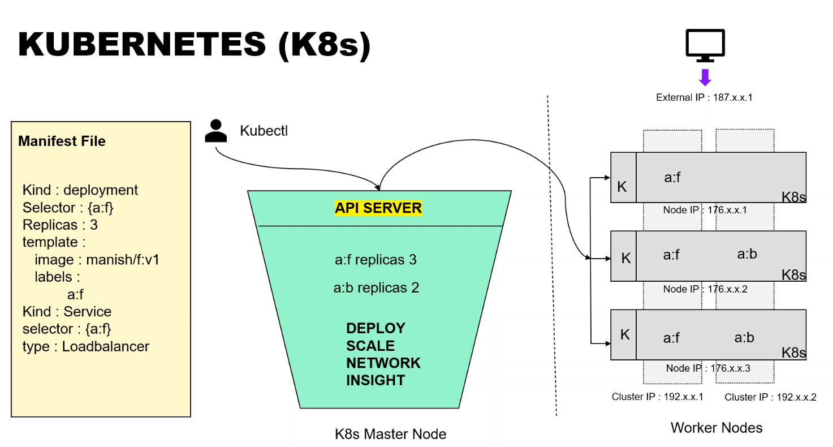

> Master node is place where u manage the application.

> At worker node, containers will be deployed.

Kubernetes Playground : <https://labs.play-with-k8s.com/>

